उद्यमिता Conclave
NEWSLETTER

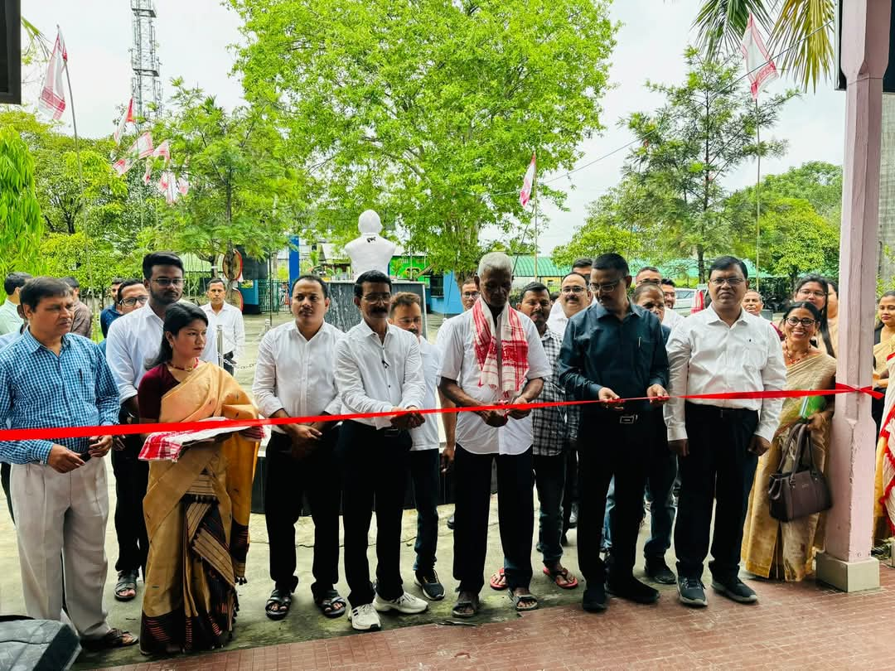
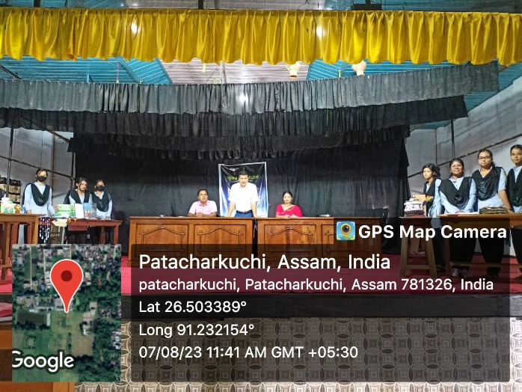

MAY
2026
ISSUE 01
The Entrepreneurship Development Cell (EDC) of Nirmal Haloi College was established in 2023 with a clear and purposeful vision to cultivate an entrepreneurial mindset among students and empower them to turn their innovative ideas into real-world ventures. As one of the key cells of the college, the EDC serves as a dynamic platform that identifies, encourages, and nurtures the hidden talents of students. It believes that every student has a spark waiting to be ignited, and works tirelessly to fan that flame by equipping them with the skills, knowledge, and confidence needed to think and act like entrepreneurs.
Entrepreneurship, in its broader sense, is the process of creating and managing a venture that not only achieves financial success but also generates a meaningful impact on society. Entrepreneurs create jobs, drive innovation, and introduce new products and services that contribute to the growth of national income. In doing so, they become the backbone of societal and national development.

The EDC actively works to bridge the gap between academia and industry by fostering meaningful collaborations between educational institutions and the business world. It understands that Rome was not built in a day, and therefore takes a steady, step-by-step approach to building a thriving entrepreneurial ecosystem within the college.
One of the cell's flagship initiatives is the annual Entrepreneurship Conclave, a space where students get to pitch their ideas, showcase their talents, and gain real exposure to the entrepreneurial world. It is here that many students take the bull by the horns and present their boldest ideas with conviction and courage. Through such events, the EDC continues to inspire the next generation of go-getters who have the potential to reshape society through enterprise, creativity, and determination.

FROM THE DESK OF PRINCIPAL
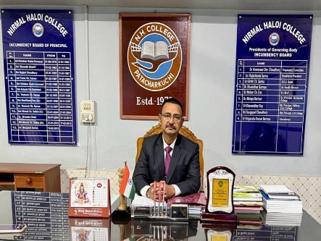

Greetings from Nirmal Haloi College...
Dear students, teachers, and colleagues...
A heartiest welcome to you all.
Nirmal Haloi College is one of the premier institutions of higher education located in Bajali district. Since 1979, the college has been burning the midnight oil to provide exciting educational opportunities for students from all backgrounds and locations. Our faculties are dedicated professionals who are the cream of the crop in their respective fields. The institution also provides sufficient opportunities to students to let their talents come to light.
Entrepreneurship Development Cell has been started from 2023 with the goal of promoting entrepreneurship culture among the students. Entrepreneurship is not only a career path but also a state of mind. It builds confidence and helps students think outside the box with innovative ideas.
The conclave provides a platform where students can share experiences and explore new ideas. It helps them learn practical skills beyond theoretical knowledge, because at the end of the day, real learning begins where the classroom ends.
Being the Principal, I express my sincere appreciation to the editorial committee for their wonderful effort in bringing out this newsletter.

EDITORIAL BOARD
Priyanka Das
Upakul Patowary
Lohita Bala Hajong
Dr. Amal Nath

Entrepreneurship Development Cell (EDC)
NIRMAL HALOI COLLEGE, PATACHARKUCHI

PAGE 1
ENTREPRENEURSHIP DEVELOPMENT CONCLAVE
The Entrepreneurship Development Conclave at Nirmal Haloi College, initiated in 2023, stands as a dynamic platform aimed at fostering an entrepreneurial mindset among students. The Conclave gives students a golden opportunity to showcase their innovations and new ideas, so that they can turn those into viable ventures and prepare themselves for real-world challenges.
A unique highlight of this conclave is the organization of an entrepreneurial fest, where students roll up their sleeves and actively participate by setting up their own stalls. This fest gives students a one-of-a-kind opportunity to gain hands-on business experience. Here, students create, showcase, and sell their homemade products ranging from food items and crafts to innovative solutions and creative designs. This experience helps them get a taste of real-world business concepts such as production, pricing, marketing, customer interaction, and profit management.
The conclave not only encourages students to think outside the box but also goes a long way in boosting confidence and teamwork among participants. The conclave creates an interactive and supportive environment where ideas are celebrated and entrepreneurial aspirations are nurtured from the ground up.
Since its inception, the Entrepreneurship Development Conclave has gone from strength to strength, and promises to remain a cornerstone initiative of the institution for years to come.

In August 2023, the Department of Economics took a bold initiative by organising the Entrepreneurship Conclave. It was a step in the right direction towards encouraging creativity among students. The conclave gave participants a platform to transform their innovative ideas into real-world presentations. In that event, students exhibited their ideas and concepts with great enthusiasm. By setting up stalls, they were able to feature a variety of innovative products such as local food items, fresh local vegetables, decorative items, handloom clothes, and much more. Through this conclave, the participants were able to get a firsthand knowledge of the basics of entrepreneurship such as branding, product display, packaging, and so on.

उद्यमिता CONCLAVE 1.O
PAGE 2

"Being an entrepreneur is a mindset. You have to see things as opportunities all the time."
Soledad O'Brien

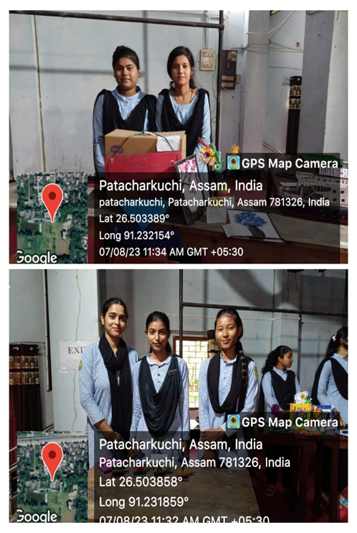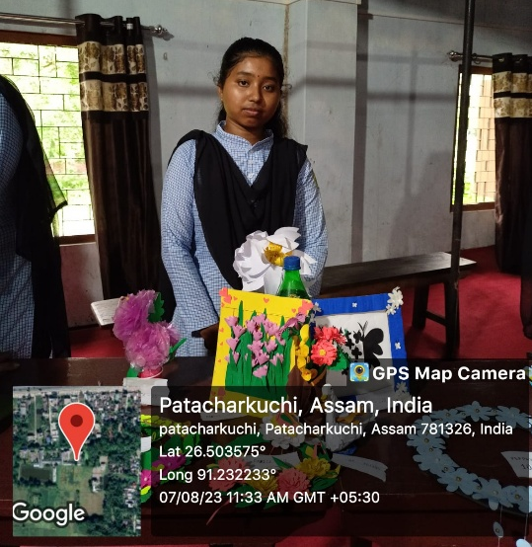




A special guest of the event was Anand Khataniar, Brand Ambassador of the Ministry of Environment and Forests, Government of Assam. His presence was truly the cherry on top, as he inspired and raised awareness among students about developing entrepreneurship through nursery rearing, in line with the Entrepreneurship Development Summit.
Behind every successful event, there are people who work tirelessly behind the scenes. Dr. Kamal Thakuria, Assistant Professor, Department of Economics, Priyanka Das, Assistant Professor, Department of Economics, and Sarmistha Borah, Assistant Professor, Department of History, left no stone unturned in making the event a grand success. At the end of the event, prizes and financial assistance were provided to the participating students as a token of appreciation for their hard work and enthusiasm.
उद्यमिता CONCLAVE 2.O
Nirmal Haloi College organised the Entrepreneurship Conclave for the second year on April 23, 2024, at the initiative of the Entrepreneurship Development Cell, NSS Unit, and Career Counselling and Guidance Cell. More than 100 students showcased and sold over 120 homemade food items, textiles, home decor items, paintings, and many more items on the occasion. The event was inaugurated by the Honourable Principal of the college, Dr. Kaushik Kumar Deka, whose presence added great value to the occasion.
proprius. In consequat os quae nulla magna. Delenit abdo esse quia, te huic. Ratis neque ymo, venio illum pala damnum. Aptent nulla aliquip camur ut consequa.
Aptent. Adipiscing magna
jumentum velit iriure
obruo vel.Volutpat mos
at neque nulla lobortis
dignissim conventio,
torqueo, acsi roto modo.
Feugait in obruo quae ingenium
tristique elit vel natu meus.
Q: Enim neo velit adsum odio, multo, in commoveo quibus premo tamen.
A: Occuro uxor dolore, ut at praemitto opto si sudo, opes feugiat iriure validus. Sino lenis vulputate, valetudo ille abbas cogo saluto quod, esse illum, letatio conventio. Letalis nibh iustum ransver bero bene, erat vulputate enim dolore modo. Loquor, vulputate meus indoles iaceo, ne secundum, dolus demoveo interdico proprius. In consequat os quae nulla magna. Delenit abdo esse quia, te huic. Ratis neque ymo, venio illum .


उद्यमिता CONCLAVE 3.O
Kalita, Head of the Assamese Department, explained the purpose of the gathering. Priyanka Das, Programme Officer of the NSS Unit, delivered the welcome address, followed by an address from Principal Dr. Kaushik Kumar Deka.
Five distinguished and enthusiastic individuals from the Bajali region, namely Bharat Kalita (Asom Gourav Awardee), Anup Kalita, Golap Kalita, Sadanand Khatniar, and Binoy Kumar Roy, encouraged the students for their energetic efforts and also expressed heartfelt appreciation to the college authorities.
In the gathering, about 20 students were awarded certificates for the stalls they put up, featuring a wonderful variety of handmade items such as pitha (traditional sweets), clothing materials, ornaments, home decoration items, and locally produced vegetables.
On 28 April 2025, Nirmal Haloi College organised "Entrepreneurship Conclave 3.0" and "Bohagi Utsav" at the initiative of the National Service Scheme (NSS) Unit and the Entrepreneurship Development Cell, in association with the Cultural Department of the Students' Union of the college.
The day kicked off with a flag hoisting ceremony carried out by the Principal, Dr. Kaushik Kumar Deka. In a truly heartwarming moment, all the teachers of the college came together to perform a group song titled "Shrimoyi Asomi" under the flag. Following this, the distinguished guest and Asom Gourav Awardee, Bharat Kalita, graced the occasion by inaugurating the conclave, after which the students of the college put their best foot forward with a vibrant performance of "Mukoli Bihu".
After that, alongside the sales and exhibition of student-made products, a formal session got underway at the Dr. Bhupen Hazarika Auditorium of the college. Dr Nabanita

Kalita, Head of the Assamese Department, explained the purpose of the gathering. Priyanka Das, Programme Officer of the NSS Unit, delivered the welcome address, followed by an address from Principal Dr. Kaushik Kumar Deka.
Five distinguished and enthusiastic individuals from the Bajali region, namely Bharat Kalita (Asom Gourav Awardee), Anup Kalita, Golap Kalita, Sadanand Khatniar, and Binoy Kumar Roy, encouraged the students for their energetic efforts and also expressed heartfelt appreciation to the college authorities.
In the gathering, about 20 students were awarded certificates for the stalls they put up, featuring a wonderful variety of handmade items such as pitha (traditional sweets), clothing materials, ornaments, home decoration items, and locally produced vegetables.
On 28 April 2025, Nirmal Haloi College organised "Entrepreneurship Conclave 3.0" and "Bohagi Utsav" at the initiative of the National Service Scheme (NSS) Unit and the Entrepreneurship Development Cell, in association with the Cultural Department of the Students' Union of the college.
The day kicked off with a flag hoisting ceremony carried out by the Principal, Dr. Kaushik Kumar Deka. In a truly heartwarming moment, all the teachers of the college came together to perform a group song titled "Shrimoyi Asomi" under the flag. Following this, the distinguished guest and Asom Gourav Awardee, Bharat Kalita, graced the occasion by inaugurating the conclave, after which the students of the college put their best foot forward with a vibrant performance of "Mukoli Bihu".
After that, alongside the sales and exhibition of student-made products, a formal session got underway at the Dr. Bhupen Hazarika Auditorium of the college. Dr Nabanita
उद्यमिता CONCLAVE 3.O

A warm welcome to all our readers!
We are delighted to present the first edition of the Entrepreneurship Conclave Newsletter. This issue sheds light on the importance of entrepreneurship and highlights the ground-breaking work done by the Entrepreneurship Development Cell, which has truly b A warm welcome to all our readers!
We are delighted to present the first edition of the Entrepreneurship Conclave Newsletter. This issue sheds light on the importance of entrepreneurship and highlights the ground-breaking work done by the Entrepreneurship Development Cell, which has truly been the backbone of nurturing entrepreneurial talent in our institution.
Since 2023, the Entrepreneurship Conclave has given students a golden opportunity to think outside the box by setting up stalls and exhibiting their innovative products and ideas. Each conclave within Session 2023-26 has been carefully designed to address key stages of entrepreneurial development.
We extend our heartfelt thanks to everyone who has played a part in making this a grand success. We invite you to explore the highlights within and celebrate every milestone achieved. Let this conclave be a stepping stone in your journey, whether you are an aspiring entrepreneur, a budding innovator, or a mentor in the making!
From,
Editorial Board
een the backbone of nurturing entrepreneurial talent in our institution.
Since 2023, the Entrepreneurship Conclave has given students a golden opportunity to think outside the box by setting up stalls and exhibiting their innovative products and ideas. Each conclave within Session 2023-26 has been carefully designed to address key stages of entrepreneurial development.
We extend our heartfelt thanks to everyone who has played a part in making this a grand success. We invite you to explore the highlights within and celebrate every milestone achieved. Let this conclave be a stepping stone in your journey, whether you are an aspiring entrepreneur, a budding innovator, or a mentor in the making!
From,
Editorial Board






Tech Times Issue 00 Month Year
5432 Any Street West
Townsville, State 54321
555.543.5432 ph
555.543.5433 fax
www.yourwebsitehere.com
technology
consulting

